SMM635 — Data Visualisation

Final course project submission template

# Visualisation #1

## The graph illustrates the monthly sales for four types of pizza in the United States pizza restaurant in 2015. We would like to know from the graph how the sales performance for four types of pizza was.

## <>

## The main insight of the graph is that most of the revenue restaurant gained has been reported from classic pizza. Further, the sales of classic pizza throughout the year were above average, which means that the classic pizza was the top-selling product in the restaurant. In general, the sales of four types of pizza decreased and increased simultaneously. Additionally, the total sales of all types of pizzas were reported high in March, which is the month that the revenue restaurant gained the most from the four types of pizzas (all above average). However, in April, there was a noticeable decline in both chicken and vegetarian pizza sales, in addition to classic and supreme pizza sales which kept rising relatively until the next month. In October, when other types of pizza decreased in sales, sales of supreme pizza increased drastically instead. Therefore, we can argue that the significant change happened in the sales of chicken and vegetarian pizza can be explained by unknown factors. An alternative explanation could be loyal customers were buying classic and supreme pizza.

# Visualisation #2

## The graph shows the peak time and off-peak time in the pizza restaurant. We would like to know from the graph when the restaurant’s peak time and off-pick time in a day and a week are.

## < >

## This graph represents the busiest time for the pizza restaurant which is during lunch from 12-13 and dinner from 17-19. The possible reason why the duration of peak time at lunchtime is less than that at dinnertime is that North Americans usually have quick lunch. Apart from the closing and opening times, around 15-16 is the time that the restaurant is less busy. However, after 17 which is the time that North Americans get off work, the restaurant starts to get busy. In addition, most pizzas are sold on the first day of the week (Sunday), and there are fewer and fewer numbers of pizzas sold to customers in the next few days. This could be explained that customers who are busy at work might tend to buy cooked food on the weekday to save time. Interestingly, fewer customers visit the restaurant on Saturday, and the possible reason could be they have more extra time to cook by themselves on weekends so they might not choose to visit a restaurant.

# Visualisation #3

## The graph provided information about the monthly average order value throughout the year. We would like to know from the graph what the customers’ purchasing behaviour throughout the year is (do they prefer buying expensive pizzas or do they prefer choosing cheap pizzas?).

## < >

## The graph represents monthly AOV dropped while the number of orders rose, and vice versa. Interestingly, from March-April, May-August and November-December, the fewer orders were taken from the restaurant, the smaller the monthly AOV was, which means customers tended to choose cheaper pizza instead of expensive ones. Only from April-May and October-November, the number of orders increased while monthly AOV rose as well, which indicates that the sales of expensive pizzas performed very well in these two months. Furthermore, increasing AOV could indeed scale revenue growth upward, therefore, if the restaurant could keep up the good sales performance from April by cross-selling or upselling which are one of the approaches to improve AOV, the growth of revenue would’ve increased in the next few months.

# Visualisation #4

## The first graph depicts the price range of pizzas in four categories customers tend to buy, and the second graph shows the number of ingredients used for making each type of pizza and the number of pizzas sold to customers. We would like to know from the first graph what type of pizzas in the specific price range customers choose to buy the most, and we also would like to know from the second graph what the average number of ingredients used in each pizza categories.

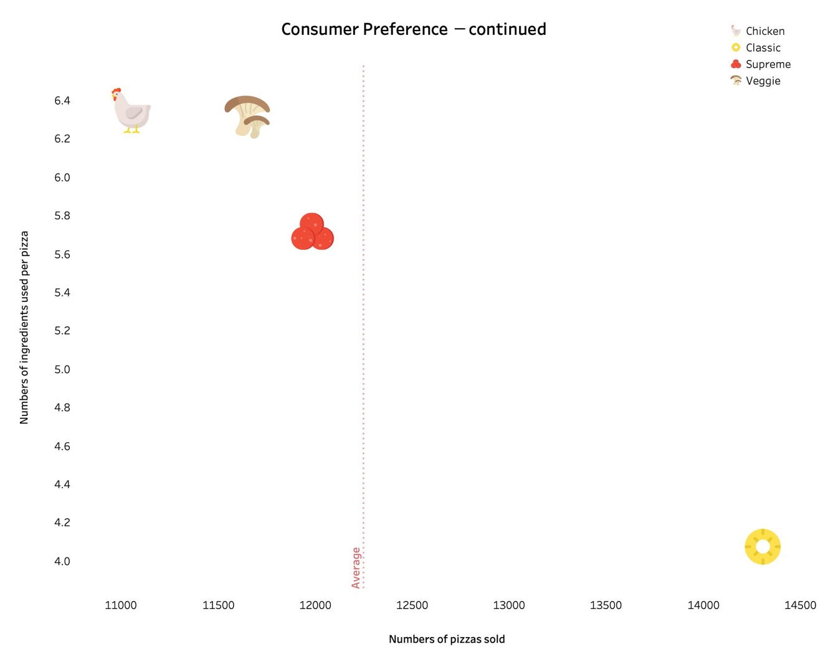

## We have known from visualization 3, customers chose to buy cheap pizzas in specific months. In the first graph above, classic pizzas stand out the most in the price range from $10 to $15 which indicates that among the four types of pizzas, classic pizza is the most common choice for customers who have limited budgets. From the second graph, the number of ingredients used for making classic pizzas is approximately 4 which is the lowest. This explains the reason why classic pizzas are inexpensive and easy to be made from the restaurant's point of view. In addition, we can also know from the first graph, customers prefer buying inexpensive pizzas (below $25) which indicates the restaurant’s primary customers are price buyers who buy products at very low price.

# Visualisation #5

## The graph shows the top five pizzas bought by customers and the ingredients used for making these pizzas. We would like to know from the graph what pizza is the most popular.

## < >

## The most popular pizza is Thai chicken pizza in large size, and it is one of the pizzas in the chicken category. Interestingly, one of the ingredients used for making Thai chicken pizza contains the most controversial pizza topping in the world, pineapple. What’s more, the third most popular pizza, Hawaiian pizza, also has pineapple as one of ingredients. Although the debate over whether pineapple belongs on pizza never ends, some customers still like to have pineapple on their pizzas which is reasonable because this pizza restaurant is in the USA. In addition, among the top 5 popular pizzas, middle and large size are the most popular which indicates that customers usually share pizzas with others. However, the size of Hawaiian pizza is small which means customers who have special tastes in pineapple tend to eat Hawaiian pizza by themselves.